Year 12 Physics
Unit 3
Gravity and motion

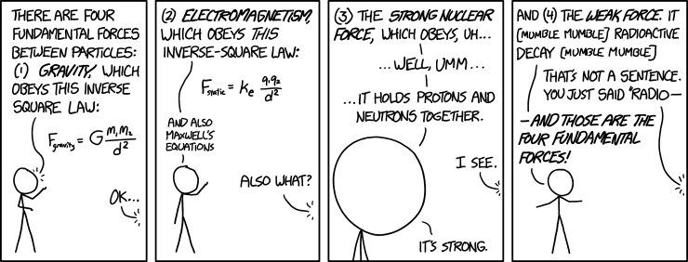
"Of these four forces, there's one we don't really understand." "Is it the weak force or the strong--" "It's gravity."
(https://xkcd.com/1489/)

Name:

Proposed timeline

Wk | # | Topic | PowerPoint | STAWA Questions | Pearson Physics
1 | 1 | Year 11 motion revision | 1-11 |  | Ch 1 and 2
1 | 2 | Year 11 motion revision | 1-11 | Set 1
1 | 3 | Acceleration down a slope | 12-14
1 | 4 | Acceleration down a slope | 12-14
1 | 5 | Projectile motion | 15-23 | Set 3
2 | 1 | Projectile motion | 15-23
2 | 2 | Projectile motion | 15-23
2 | 3 | Projectile motion | 15-23
2 | 4 | Task 0: Year 11 Revision Quiz
2 | 5 | Circular motion - velocity | 24-27 | Set 4
3 | 1 | Circular motion - velocity | 24-27
3 | 2 | Circular motion - acceleration | 28-30
3 | 3 | Task 1 Practical – Factors affecting circular motion
3 | 4 | Circular motion - acceleration | 28-30
3 | 5 | Circular motion - force | 31-35
4 | 1 | Circular motion - force | 31-35
4 | 2 | Circular motion – banked track | 36-39
4 | 3 | Task 1: Factors affecting circular motion validation
4 | 4 | Interhouse Swimming Carnival
4 | 5 | Circular motion – banked track | 36-39
5 | 1 | Labour Day
5 | 2 | Circular motion – vertical plane | 40-45
5 | 3 | Revision
5 | 4 | Task 2: Projectile and centripetal topic test
5 | 5 | Newton’s law of universal gravitation | 46-50 | Set 5
6 | 1 | Newton’s law of universal gravitation | 46-50
6 | 2 | Field theory | 51-55
6 | 3 | Field theory | 51-55
6 | 4 | Kepler’s law of planetary motion | 56-60
6 | 5 | Kepler’s law of planetary motion | 56-60
7 | 1 | Satellites | 61-64
7 | 2 | Satellites | 61-64
7 | 3 | Parent Teacher Interviews
7 | 4 | Torque | 65-72 | Set 2
7 | 5 | Torque | 65-72
8 | 1 | Torque | 65-72
8 | 2 | Equilibrium | 73-81
8 | 3 | Equilibrium | 73-81
8 | 4 | Task 3: Moments practical test
8 | 5 | Equilibrium | 73-81
9 | 1 | Electromagnetism |  | Set 9 | Ch 5
9 | 2 | Electromagnetism
9 | 3 | Revision
9 | 4 | Task 4: Planet motion and moments test
9 | 5 | Electromagnetism |  |  | C

SCSA ATAR Syllabus
https://senior-secondary.scsa.wa.edu.au/syllabus-and-support-materials/science/physics

Science Understanding
- the movement of free-falling bodies in Earth’s gravitational field is predictable
- all objects with mass attract on another with a gravitational force; the magnitude of this force can be calculated using Newton’s Law of Universal Gravitation
This includes applying the relationship
$$F_{g}=G\frac{m_{1}m_{2}}{r^{2}}$$
- objects with mass produce a gravitational field in the space that surrounds them; field theory attributes the gravitational force on an object to the presence of a gravitational field
This includes applying the relationship
$$F_{weight}=mg$$
- when a mass moves of is moved from one point to another in a gravitational field and its potential energy changes, work is done on the mass by the field
This includes applying the relationships
$E_{p}=mg∆h$, $W=Fs$, $W=∆E$, $E_{k}=\frac{1}{2}mv^{2}$
- gravitational field strength is defined as the net force per unit mass at a particular point in the field
This includes applying the relationship
$$g=\frac{F_{g}}{m}=G\frac{M}{r^{2}}$$
- the vector nature of the gravitational force can be used to analyse motion on inclined planes by considering the components of the gravitational force (that is, weight) parallel and perpendicular to the plane
- projectile motion can be analysed quantitatively by treating the horizontal and vertical components of the motion independently
This includes applying the relationships
$v_{av}=\frac{s}{t}$, $a=\frac{v-u}{t}$, $v=u+at$, $s=ut+\frac{1}{2}at^{2}$, $v^{2}=u^{2}+2as$, $E_{k}=\frac{1}{2}mv^{2}$

- when an object experiences a net force of constant magnitude perpendicular to its velocity, it will undergo a uniform circular motion, including circular motion on a horizontal plane and around a banked track; and vertical circular motion
This includes applying the relationships
$v=\frac{2πr}{T}$, $a_{c}=\frac{v^{2}}{r}$, $resultant F_{c}=ma_{c}=\frac{mv^{2}}{r}$
- Newton’s Law of Universal Gravitation is used to explain Kepler’s laws of planetary motion and to describe the motion of planets and other satellites, modelled as uniform circular motion
This includes deriving and applying the relationship
$$\frac{T2}{r3}=\frac{4π2}{GM}$$
- when an object experiences a net force at a distance from a pivot and at an angle to the lever arm, it will experience a torque or moment about that point
This includes applying the relationship
$$τ=rF\sin{θ}$$
- for a rigid body to be in equilibrium, the sum of the forces and the sum of the moments must be zero
This includes applying the relationships
$\sum{F=0}$, $τ=rF\sin{θ}$, $\sum{τ=0}$
Science as a Human Endeavour
Artificial satellites are used for communication, navigation, remote-sensing and research. Their orbits and uses are classified by altitude (low, medium or high Earth orbits) and by inclination (equatorial, polar and sun-synchronous orbits). Communication via satellite is now used for global positioning systems (GPS), satellites phones and television. Navigation services support management and monitoring of traffic and aircraft movement. Geographic information science uses data from satellites to monitor population movement, biodiversity and ocean currents.
Motion revision

Revise Law of conservation of Energy and Vectors (see back of booklet)

Generalised method for tackling motion problems
- Draw a diagram.
- Assign values to variables (v, u, t, a, s etc.).
- Assign direction (typically up is positive, down is negative, right is positive, left is negative).
- Select appropriate equation, substitute variables, solve for unknown.
- Write answer to 3 significant figures with direction as appropriate.

Examples
- A rock is dropped out of a hot air balloon that is hovering stationary 200m above the ground.
  - With what speed does the rock hit the ground?
  - How long does the rock take to fall?
  - If the hot air balloon is moving upwards at 5.00 ms⁻¹ how long would the rock take to drop 200 m?

- A rocket takes off vertically upwards at 15.0 m s⁻¹.
  - What is the maximum height reached by the rocket?
  - How long will the rocket take to fall back to its original position?

- A boy takes a shot with a basketball with a vertical velocity of 6.50 m s⁻¹ and watches as it comes down through the hoop, 1.05 m above his hand.
  - Find the total flight time for the ball from hand to hoop.
  - Find the velocity of the ball as it strikes the hoop.
  - An opponent is running towards the hoop at 35 km/h. He is 15.0 m away from being in position to grab the ball as it rebounds. Will he be there in time?

- A car is accelerated from 15.0 m s⁻¹ to 48.0 m s⁻¹ in 12.0 s.
  - Calculate the average velocity
  - Calculate acceleration
  - Calculate displacement

Revision – Equations of motion
- A ball is thrown vertically upwards at 20 ms⁻¹.
- What is the maximum height reached by the ball?
- How long will the ball take to fall back to its original position.

- A thrill seeker falls off a bungy jumping tower.
  - What is their velocity 1.10s after they left the platform? Assume elastic has not applied a force yet.
  - How far has the bungy jumper fallen during the 1.10s?
  - What is the maximum velocity the bungy jumper achieves before beginning to slow down? He falls 10.4m before the elastic applies a force.
  - If a bungy jumper jumps upwards a distance of 0.500m, what initial velocity is necessary to reach that height?

- A boy standing on a bridge throws a ball vertically upwards at 3.00 ms⁻¹ and watches as it lands in the river 6.50m below.
- Find total time stone in flight.
- Find the velocity of stone as it strikes the water.
- A boat 50m away as the boy throws the stone, is travelling at 50km/h towards the bridge. Will the stone hit the boat if it passes the exact spot where the stone will land?

- A rocket is uniformly accelerated from rest at 8 ms⁻² for a period of 12 s. Find:
- final velocity.
- displacement
- Average velocity.

- A car is accelerated from 17 ms⁻¹ to 44 ms⁻¹ in 18 s. Calculate the :
- Average velocity
- Acceleration
- Displacement in this time.

Ans: 1a) 20.4 m b) 4.08 s 2a) 10.8 m s⁻¹ down b) 5.93 m down c) 14.2 m s⁻¹ down d) 3.13 m s⁻¹ up 3a) 1.50 s b) 11.7 m s⁻¹ down c) no 4a) 96 ms⁻¹ b) 576m c) 48 ms⁻¹ 5a) 30.5 ms⁻¹ b) 1.5 ms⁻¹ c) 549 m

- Label all the forces acting on the objects below






Potential energy
- All objects in a gravitational field have potential energy as a result of their position within the field
- When an object moves through a gravitational field causing its potential energy to change, work has been done on it by the field
- Recall the following equations:

$E_{p}=mg∆h$ $W=Fs$ $W=∆E$ $E_{k}=\frac{1}{2}mv^{2}$
g
g_{perpendicular}
g_{parallel}
θ

Motion on an inclined plane
- Vertical gravitational acceleration is at 9.8 ms⁻²
- An object on a slope will accelerate at a slower rate
- The acceleration down a slope due to gravity is the component of gravity acting parallel to the slope (ignore friction)
- The acceleration down the slope is the component of gravitational acceleration acting parallel to the slope
$$g_{parallel}=g\sin{θ}$$
- Should always be less than 9.8 ms⁻²

g
g_{perpendicular}
g_{parallel}
θ

Example:

Determine the driving force applied to a 1 580 kg car moving at 60.0 kmh⁻¹ up a slope with an angle of 5.80⁰ The friction is 1020 N.

Projectile motion
- Motion of projectiles through two dimensions can be handled very effectively by considering vertical and horizontal components separately
- Use normal equations of motion:

$v_{av}=\frac{s}{t}$ $a=\frac{v-u}{t}$ $v=u+at$ $s=ut+\frac{1}{2}at^{2}$ $v^{2}=u^{2}+2as$
$E_{k}=\frac{1}{2}mv^{2}$

- Vertical component typically used to find time of flight, normally work out vertical component first
- Gravitational acceleration typically results in a parabolic projectile path

Projectile motion forces
- Projectile motion often defined as when the only force acting on an object is gravity (weight)
- Friction (air resistance) is still present but typically ignored in calculations
- No thrust force! Once a cannonball has exited the cannon it is not subjected to any forwards force
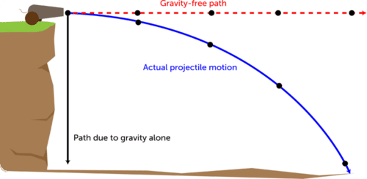
(https://www.ck12.org/physics/projectile-motion/lesson/Projectile-Motion-MS-PS/)

Examples
- A 5.7 kg cannonball is fired horizontally from the top of a 15 m cliff with a muzzle velocity of 212 m s⁻¹. How far does the cannonball travel?

- Bob Beamon’s record breaking long jump (8.9 m) in the 1968 Olympics resulted from an initial velocity of 9.5 m s⁻¹ at an angle of 40◦ to the horizontal. Determine the following.
  - u_{v}
  - u_{h}
  - t
  - Range
  - Max height

- A golfer hits a ball with a velocity of 25 m s⁻¹ at an angle of 60◦ to the horizontal. Determine the following.
  - u_{v}
  - u_{h}
  - t
  - Range
  - Max height

- A footballer kicks a ball at 30 m s⁻¹ at an angle of 30◦ to the horizontal. Determine the following.
  - u_{v}
  - u_{h}
  - t
  - Range
  - Max height
  - To achieve maximum range what angle should the ball be kicked at?

- A diver runs and dives off a 10 m high tower with a velocity of 4.0 m s⁻¹ at an angle of 70◦ to the horizontal. Determine:
  - Maximum height reached.
  - Horizontal distance to reach maximum height.
  - Total distance travelled horizontally
  - Total time in the air
  - Velocity on landing.

Air Resistance

Ignoring air resistance the path of projectile is parabolic.

Air resistance opposes the direction of motion of projectile. It has the following effects on the pathway of projectile.

- Reduce its maximum height and peaks earlier
- Reduce its calculated range
- Increase angle of descent.

Draw a diagram of soccer ball being kicked to make a goal with pathway a) ignoring air resistance and pathway b) including air resistance.

For a projectile moving in air:

- Why is the angle of descent greater than the angle of projection?
- Is the time on upward journey different to time on downward journey? (Hint: consider vertical forces acting on projectile up and down)

Projectile Motion Practical:

Aim: to determine how the angle affects the range of the projectile b) calculate the initial velocity.

SAFETY GLASSES MUST BE WORN AT ALL TIMES

Variables: Independent:______________________________________________
Dependent:_______________________________________________
Controlled:_______________________________________________

Equipment: projectile gun, tape measure or metre rule.

Procedure:

- Set up projectile gun with an angle of 30⁰ and draw back to the engage the notch. Fire so ball lands on 2nd table.
- Measure range.
- Repeat process with different angles.
Results:
Effect of changing angle
Angle (⁰)

Range ( )

Calculations:

- For first angle measurement determine the initial velocity of the projectile. [hint: simultaneous equations required]
- Using initial velocity determine the expected range of the 2nd measurement and compare to actual range achieved.
- Determine the maximum vertical height above starting level achieved by 3rd measurement.

Discussion:

Determine the uncertainty of the initial velocity.

State findings, explanation and sources of errors and improvements. ________________________________________________________________________________________________________________________________________________________________________________________________________________________________________________________________________________________________________________________________________________________________________________________________________________________________________________________________________________________________________________________________________________________________________________________________________

Conclusion:

__________________________________________________________________________________________________________________

Circular motion
- If an object experiences a net force of constant magnitude perpendicular to its velocity it will undergo uniform circular motion

weight towards center of
Earth perpendicular to instantaneous velocity
instantaneous velocity

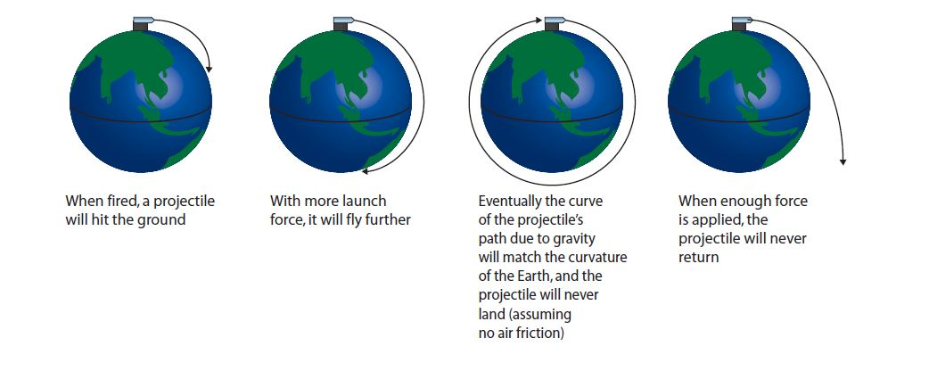
(http://www.hscstudyguides.com.au/hsc-physics-course-summary/hsc-physics-course-summary-space/rocket-launches-orbital-motion/)

Velocity in circular motion

$$v=\frac{2πr}{T}$$
$$v=velocity \left(m s^{-1}\right)$$
$$r=radius \left(m\right)$$
$$T=period (s)$$

- Simply a version of $speed=\frac{distance}{time}$
- 2πr is the circumference so distance travelled in a complete loop (N/A, 2010)
- T is the time taken for a complete loop
- Instantaneous velocity will always have a direction tangential to the circular path
- Recall that $T=\frac{1}{f}$

Example
- If it takes the moon 27.32 days to orbit the Earth, how fast is it travelling? Assume Earth-Moon distance on data sheet is center to center.

Acceleration in circular motion
$$a_{c}=\frac{v^{2}}{r}$$
$$a_{c}=centripetal acceleration \left(m s^{-2}\right)$$
$$v=velocity \left(m s^{-1}\right)$$
$$r=radius (m)$$

- Much more complicated to derive but results in very simple equation
- Centripetal refers to the direction, that is, perpendicular to the direction of movement, directly towards the center of curvature

Example
- A train is travelling at 50 m s⁻¹ round a curve of radius 6000 m. What is its acceleration?

- A washing machine spins its drum at 1200 rpm. The diameter of the drum is 35 cm.
  - Find the acceleration of the tub.
  - Find the speed of the rim of the tub.

Force in circular motion

$$resultant F_{c}=ma_{c}=\frac{mv^{2}}{r}$$
$$F_{c}=centripetal force \left(N\right)$$
$$a_{c}=centripetal acceleration \left(m s^{-2}\right)$$
$$v=velocity \left(m s^{-1}\right)$$
$$r=radius (m)$$

- Derived from 2nd law and centripetal acceleration equation
- Once again direction is always towards the center of curvature, perpendicular to the instantaneous velocity

Examples
- A 900 kg car moving at 10 m s⁻¹ takes a turn around a circle with a radius of 25 m. Determine the acceleration and the net force acting upon the car.

- A 95 kg footballer makes a turn on the pitch. They sweep out a path which is a portion of a circle with a radius or 12 m. The footballer makes a quarter turn around the circle in 2.1 s. Determine the speed, acceleration and net force acting upon the halfback.

Horizontal plane circular motion

- Simplest scenario as normal force and centripetal force are always perpendicular so entirely independent
- For a moving object to corner (change direction) it has to experience a force in the direction it is turning
- For a car on flat ground the only source of this force can be friction, if not enough friction between the car and the ground it will skid out.

The Gravitron: Read PS 12 Physics for WA pg 68 and make notes

____________________________________________________________________________________________________________________________________________________________________________________________________________________________________________________________________________________________________

Example
A swingball with a mass of 57 g is swinging freely in a horizontal circular path. The cord is
15 m long and is at an angle of 60◦ to the vertical. Draw a diagram to find the following.
- Radius of the ball’s path
- Net Force acting on the ball
- Tension in the cord
- Speed of the ball

Banked track circular motion
- To allow vehicles to take corners more quickly racetracks have banked turns
- Normal force is no longer perpendicular to the centripetal force so it contributes to it, allowing for faster cornering
- If N_{h}=F_{C} for a particular turn, it can be made on a perfectly frictionless surface
- If N_{h}>F_{C} then vehicle needs friction to prevent it from sliding inwards
- If N_{h}<F_{C} then vehicle needs friction to prevent it from sliding outwards

Banked track calculations
- Normal force increased during circular motion such that the horizontal component of the normal force supplies the centripetal force
- Conveniently the vertical component of the normal force becomes equal to the weight force
$$N_{h}=mg\tan{θ}$$
- Typically assume 0 friction so
$$F_{C}=N_{h}=mg\tan{θ}=\frac{mv^{2}}{r}$$

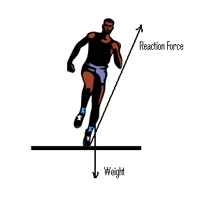
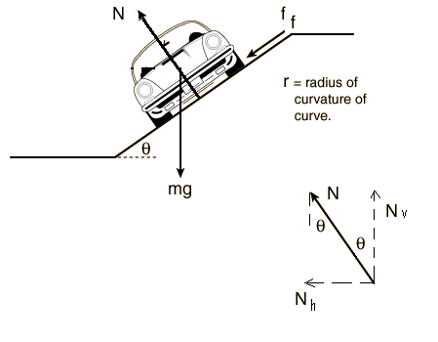

Banked track applied to other contexts
Same calculations apply to:
- a runner leaning into a corner (reaction force replaces normal)
- banking aircraft (lift replaces normal)
- pendulum (tension replaces normal)

Example:
A 1250 kg car travels on a roadway that is banked at an angle of 25.0⁰ to the horizontal. The radius of the circular roadway is 52.0 m
- Determine the net force if the car is moving at the designed speed.
- What is the designed speed for the banked roadway?

Vertical plane circular motion
- In circular motion in a vertical plane weight is sometimes in the opposite direction to the centripetal force, is sometimes in the same direction, and is sometimes perpendicular; most complex scenario

Object on a rope
- Weight is opposite direction as centripetal force so
$$tension=\left|centripetal force\right|+\left|weight\right|$$
- Weight is perpendicular to centripetal force so
$$tension=centripetal force$$
- Weight is same direction as centripetal force so
$$tension=\left|centripetal force\right|-\left|weight\right|$$

1
2
3

Loop-the-loop
- In circular motion in a vertical plane weight is sometimes in the opposite direction to the centripetal force, is sometimes in the same direction, and is sometimes perpendicular; most complex scenario
- Weight is opposite direction as centripetal force so
$$reactionforce=\left|centripetal force\right|+\left|weight\right|$$
- Weight is perpendicular to centripetal force so
$$reaction force=centripetal force$$
- Weight is same direction as centripetal force so
$$reaction force=\left|centripetal force\right|-\left|weight\right|$$

1
2
3

Minimum speed
- Any loop has a minimum speed needed to make the loop
- Occurs when the reaction force is 0 therefore
- Since weight is same direction as centripetal force
$$reaction force=\left|centripetal force\right|-\left|weight\right|$$
$$0=\left|centripetal force\right|-\left|weight\right|$$
$$\frac{mv^{2}}{r}=mg$$
- If a vehicle attempts the loop at a lower speed it will fall

Examples
- A 150 g ball on the end of a 110 cm line if swung in a vertical circle.
  - Determine the minimum speed the ball must have at the top of the arc.
  - Calculate the tension in the line at the bottom of the arc assuming the ball is moving at twice the speed at the top.

40 m
Start
A
B

- The radius of the loop is 10 m, the mass of the car is 150 kg. Find the reaction forces at A and B assuming no energy is lost.

- At what speed will a 1500 kg car experience lift-off on a speed bump of radius 2.5 m?

Gravitational acceleration
- Ignoring air resistance all objects on Earth accelerate towards the center of the Earth in a consistent manner
- A value of 9.8 m s⁻² is used as an average value for gravitational acceleration but there is local variation

In Rio de Janeiro in 2016, the same jump will get an athlete 0.25% higher (>1cm) than in London four years prior.
(https://xkcd.com/852/)
Newton’s law of universal gravitation

- Newton came to the conclusion that all masses attract each other at a distance, with size of the force being proportional to the masses and inversely proportional to the square of the distance between them

$$F_{g}=G\frac{m_{1}m_{2}}{r^{2}}$$

$$F_{g}=gravitational force \left(N\right)$$
$$G=6.67×{10}^{-11} N m^{2} {kg}^{-2}=Newtonian constant of gravitation \left(N m^{2} {kg}^{-2}\right)$$
$$m^{1}=mass of object 1 \left(kg\right)$$
$$m^{2}=mass of object 2 \left(kg\right)$$
$$r=distance between objects (m)$$

- Newton never devised a satisfactory explanation for why or how gravity acted on distant objects but his equation is extremely effective at predicting what gravity does to distant objects

- Newton’s Law of Universal Gravitation can be used to determine the acceleration of any mass on Earth using the values for the Newtonian constant of gravitation, mass of the Earth and mean radius of the Earth off the data sheet

$$g=\frac{F_{g}}{m_{2}}=G\frac{m_{1}m_{2}}{r^{2}}÷m_{2}$$

- A familiar number, however it relies on mean radius of the Earth and assumes the mass of the Earth is homogenously distributed throughout the Earth or even that it is all located at the centre of the Earth

Factors influencing local gravitational acceleration

$$F_{g}=G\frac{m_{1}m_{2}}{r^{2}}$$

- Altitude; the radius variable is referring to distance from the center of the Earth. Planes at cruising altitude will experience slightly diminished gravitational acceleration.
- Latitude; the Earth is not a true sphere, the radius at the poles is slightly less than that at the equator making gravitational acceleration slightly higher at the poles
- Local geology; the Earth’s mass is not homogenously distributed. If higher density rocks are present underfoot the gravity will be slightly higher (very small effect but measurable, used in mineral exploration)

Field theory
- Idea that mass creates a gravitational field that pulls other mass towards it at a distance
- At any point in space the gravitational acceleration experienced by an object is equal to the sum of each of the contributions from different masses

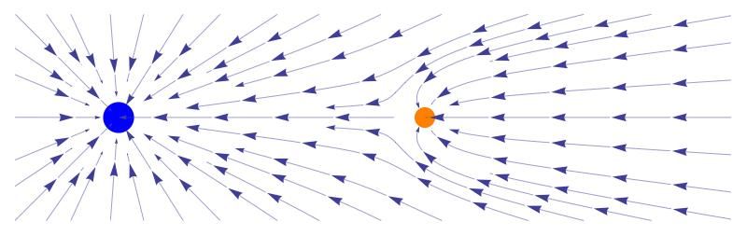
(http://diaryofnumbers.blogspot.com/2011/02/bill-oreilly-problem.html)

Field lines
- Field strength increases as lines become closer together
- At the large scale gravitational fields are radial, with field lines converging at the
center of mass
- At the small scale the field appears uniform with even spacing of “parallel”
field lines

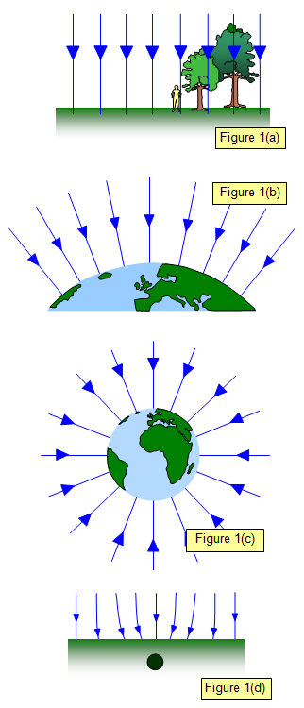



(http://www.schoolphysics.co.uk/age16-19/Mechanics/Gravitation/text/Gravitational_field_intensity/index.html)

Field strength away from the surface of the Earth

$$g=\frac{F_{g}}{m}=G\frac{M}{r^{2}}$$

- Field strength defined as the net force per unit mass at a particular point in a field
- Force per unit mass is equal to acceleration
- Can be used to determine field strength at points above or below the surface of the Earth, or even other large objects (moons/planets/stars)
- If multiple large bodies are present simply sum the components from each one as vectors

Examples
- Determine the gravitational field strength experienced by a plane at a high cruising altitude (12.5 km)

- What is the gravitational field strength experienced by an object directly between the Earth and Moon, 3.742 x 10⁷ m above the surface of the Moon

Kepler’s laws of planetary motion
Describe the motion of planets around the Sun, extend to any satellite

- The orbit of a planet is an ellipse with the Sun at one of the two foci
- A line segment joining a planet and the Sun sweeps out equal areas during equal intervals of time
- The square of the orbital period of a planet is proportional to the cube of the semi-major axis of its orbit


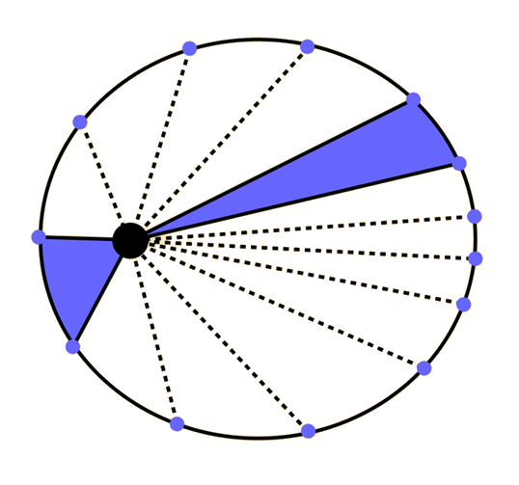

(http://hyperphysics.phy-astr.gsu.edu/hbase/kepler.html)

(https://xkcd.com/21/)

For our purposes we generally ignore the first two laws, pretending that the
orbits are circular with the object travelling at constant speed
This simplifies the third law to:

- The square of the orbital period of a planet is proportional to the cube of
the radius of its orbit

Derivation of simplified Kepler’s third law equation
- An orbit is circular motion caused by gravity so two equations can be combined

$$F_{c}=\frac{mv^{2}}{r}=F_{g}=G\frac{mM}{r^{2}}$$
$$\frac{mv^{2}}{r}=G\frac{mM}{r^{2}}$$
$$v^{2}=G\frac{M}{r}$$

recalling that $v=\frac{2πr}{T}$

$$\frac{4π^{2}r^{2}}{T^{2}} =G\frac{M}{r}$$
$$\frac{4π^{2}r^{3}}{GM} =T^{2}$$
$$T^{2}=\frac{4π^{2}}{GM}r^{3}$$

- The square of the orbital period of a planet is proportional to the cube of the radius of its orbit

Examples
- What radius do geostationary satellites (T=1 day) orbit at?

- The planet Mars has a diameter of 6800 km. A satellite is in orbit 5000 km above the planet’s surface traveling at a speed of 7100 m s⁻¹.
  - How long does it take to orbit?
  - What is the centripetal acceleration needed at this speed?
  - What is the acceleration due to gravity at this distance?
(Mass of Mars = 6.42 x 10²³ kg)
  - Will it remain in that orbit?

Weightlessness vs Apparent Weightlessness

- Weightlessness can only occur when no gravitational force is acting on the object.
- Apparent weightlessness occurs when an object is not experiencing a normal force - freefall
- Astronauts in satellites feel weightless. This is because they are falling at the same rate as the satellite, not because there is no gravity - they experience apparent weightlessness.
- This can occur even when you are standing on a surface when there is no normal force being applied if the surface is accelerating away at the same rate as you are falling e.g. in a lift in free fall.
- Astronauts train for weightless conditions by being carried in a plane that dives in a parabolic path. This is known as the "Vomit Comet".

Artificial satellites
Artificial satellites are used for communication, navigation, remote-sensing and research.
- Communication via satellite is now used for global positioning systems (GPS), satellites phones and television.
- Navigation services support management and monitoring of traffic and aircraft movement.
- Geographic information science uses data from satellites to monitor population movement, biodiversity and ocean currents.

Satellites by altitude
Low Earth orbit (LEO): 180-2000 km altitude
- ISS, most satellites
Medium Earth orbit (MEO): 2000-35786 km altitude
- Navigation (e.g. GPS), communication and geodetic/space environment science satellites
Geosynchronous orbit (GEO): 35786 km altitude
- Period of orbit same as length of a day, keeps pace with rotation of the Earth
- Includes geostationary orbits those where the satellite remain directly over a point on the surface
High Earth orbit (HEO): >35786 km altitude
- Less used

Satellites by inclination
Inclination measured as deviation from alignment with the equator
- Equatorial (0◦ inclination)
- Polar (90 ◦ inclination)
- e.g. GPS satellites have an inclination of roughly 55 ◦
Sun-synchronous
- specific combination of inclination and altitude
- Maintains constant relationship with the Sun
- e.g. can ensure satellite is always in sunlight so solar panels can always function
- Useful for imaging, weather satellites and spying

Centre of mass
- Centre of mass is the single point where the weighted relative position of the distributed mass sums to zero
- Located at the geometric center of an object (assuming homogenous density)
- The point at which you could balance the object on your finger
- It is the point that a uniform force can be thought of as acting on the object
- If a force is applied to an object away from its center of mass this causes rotation and ‘torque’
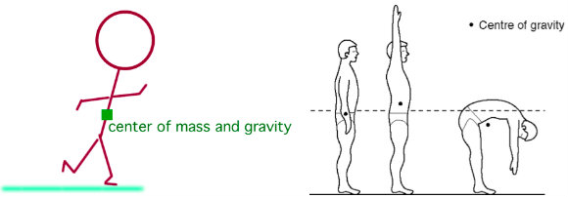
(https://physics.stackexchange.com/questions/232684/does-human-body-have-a-centre-of-mass)

Irregular shaped object
To find the centre of mass of an irregular shaped object use a plumb line.

Stability
- An object will fall over if its weight vector is outside its base of support
- Weight vector acts down from center of mass
- Increase stability by:
  - Lowering the center of mass
  - Widening the base
- E.g. wine glass vs whisky glass vs tumbler

Torque
$$τ=rF\sin{θ}$$

$τ$ = torque (N m)
r = lever arm / radius (m)
F = Force (N)
θ = angle between direction of force and lever arm (often 90◦ eliminating sinθ)

- known as ‘torque’, ‘moment of force’, or just ‘moment’
- measure of rotational force
- symbol $τ$(lower case Greek letter tau)
- pseudovector so has magnitude and direction

Direction for torque
- Torque does require a direction
- For our purposes just give a descriptive direction, often clockwise or counter-clockwise but this is not following convention
- The conventional direction of a torque is perpendicular to both the direction of the force and the direction of the lever arm, determined using the right hand grip rule
- At our level this can be ignored but it has significance when dealing with angular momentum

Examples
What torque is created when holding a 4 kg 1.3 m plank out in front of you?

A woman whose car has a flat tyre has two wheel-nut spanners in the boot of her car. One wheel spanner is 15 cm long, the other is 75 cm long.
  - Which spanner will require least effort?
  - If the woman is capable of exerting a force of 45 N perpendicular to the spanners what is the maximum torque she can apply?

Determine the torque in the diagram shown:
1.5 m
30°
12 N

Timmy wants to determine the center of mass of a 5.45 m long crocodile. He wrangles it onto two scales. Scale A sits 1.73 m back from the tip of the croc’s head and reads 564 kg. Scale B sits 2.1 m up from the tip of the croc’s tail and reads 422 kg. Find the location of the crocodile’s center of mass.

Equilibrium
- For a rigid body to be in equilibrium the sum of all forces and the sum of all moments on the object must be zero

$\sum{F=0}$ $\sum{τ=0}$

- This is referred to as static equilibrium and requires both translational and rotational equilibrium
- Therefore there is:
No net force
No rotation
No acceleration

Forces in equilibrium: Translational equilibrium

Vector diagram:
- Add vectors head to tail and a closed figure should be drawn if in equilibrium as net force = 0.
- F(up)= F(down) and F(left) = F (right)

General equilibrium problem methods
- Identify beam
- Draw in all the forces acting on a beam
- Choose pivot point to cancel unknown force
$$τ_{c}=τ_{ac}$$
$$F_{up}=F_{down}$$
$$F_{right}=F_{left}$$

Examples
- Is the system below balanced?

2 kg
3 kg
6 m
4 m

- Is the system below balanced?

4 kg
3 kg
6 m
3 m
3 kg
5 m

- A 20 m long bridge with a weight of 100 000 N spans a valley. A 200 000 N truck sits 6 m from one end (A) of the bridge. Find the reaction force at each end, A and B.

A
B
R₁
R₂
100000 N
200000 N

- While painting a tall building, a 70.09 kg painter stands 4.00 m form the end of a 6.00 m long plank that is supported by a rope at either end. The plank has a mass of 320.0 kg. Determine the tension in each rope.

Diagram:

- A uniform cantilever beam used as a viewing platform extends 10.0 m beyond two supports which are 8.00 m apart. If the beam has a mass of 30.0 kg, determine the magnitude and direction of the forces that the supports must supply so that the beam is in static equilibrium.
Draw diagram:

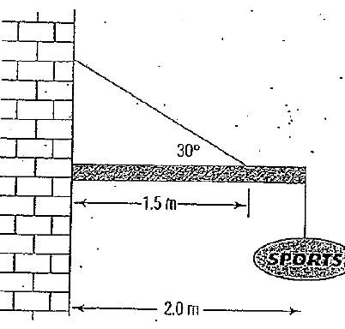
- A 10.2 kg sign is suspended from the end of a uniform
2.00 m long, 25.5 kg weight cantilevered beam outside
a shop. The beam is further supported by an effectively
light wire that makes an angle of 30.0⁰ to the beam.
The wire is attached at a point 1.5m from the wall.

- Find the tension in the wire.
- Determine the force acting on the beam supplied
by the wall.

Rules for a ladder
- Draw diagram.
- Draw in weight of ladder and weight of person on ladder.
- Reaction force at top of ladder will be perpendicular to surface it is applied to. (wall is horizontal)
- Direction of Reaction force of ground is NOT up the ladder. Usually pivot is placed here.

Revision – Conservation of energy
- State the law of conservation of energy:

- If a 50 g bob of a pendulum is pulled to one side to make 30⁰ with the vertical and the length of the line is 45 cm, what is the speed of the bob when the bob is allowed to fall and reach its lowest position?

- Write and simplify the equation for the above calculation.

- What height will the bob reach? Will it always reach this height? Explain.

- Consider a rollercoaster that is 120m above the ground travelling at 5 ms⁻¹ when it falls through a drop to be 35 m above the ground.
- What is the coasters velocity at the bottom of the dip?
- If 10% of the energy is lost to heat what height will it reach on the other side and still be moving at 2.5 m/s?
- Write the general equation for a) and b)

- Write the efficiency equation.

- What form of energy is “degraded energy”? What is meant by this term?

- What did you choose as your frame of reference in:
  - The pendulum
  - The rollercoaster

- What is the theoretical maximum speed of a rollercoaster car starting at a height of 50.0m above the lowest point on the track?
- A 900.0 kg roller coaster car starts its run 75.0 m above the ground, and rolls to a height of 62.0 m up a smooth U-shaped track before slowing to a stop. How much energy has been lost due to friction and other causes?
- The owner of the fairground wants a roller coaster that will travel at 100.0 km/h at the bottom of the first hill. How high will it need to start? Ignore friction.
- Will you travel faster, slower or at the same maximum speed if you are the only person on a roller coaster ride, compared with sharing the ride with nine other people. Ignore frictional effects.

Revision – vectors
- Compare vectors and scalars
- List 5 examples each of scalars and vectors
- Compare true bearing and compass bearing with examples
- A tennis ball moving at 5.00 ms⁻¹ bounces straight back off a wall at 3.00 ms⁻¹ Determine the balls change in velocity.
- A bullet ricochets off a wall striking the wall at 100km/h at 30⁰ to the wall. The bullet leaves the wall at 70km/h at a 60⁰ angle to the wall. Determine its change in velocity.
- You are applying a 60N force to your dog’s leash at an angle of 40⁰ to the horizontal. Find the component forces.
- A motor boat traveling 4 m/s, East encounters a current traveling 3.0 m/s, North.
  - What is the resultant velocity of the motor boat?
  - If the width of the river is 80 meters wide, then how much time does it take the boat to travel shore to shore?
  - What distance downstream does the boat reach the opposite shore?
- A motor boat can travel at 4 m/s in still water.
  - In which direction must the boat head if it reaches the other shore directly across from where it set off from, with the river moving at 2m/s
  - What is the boats resultant velocity?
- a 1 000 kg car is on a frictionless slope that is at an angle of 15⁰ to the horizontal.
  - Draw a diagram and draw in all force vectors.
  - Find the net force on the car.
- An 85.0 kg (boy + skateboard) boy is freewheeling on his skateboard down a 25.0⁰ slope. If the frictional forces experienced is 10% of the normal force. Determine the net force down the slope.
- If a roller coaster has a mass of 1.00 tonne including passengers, what force will be accelerating it down a track that is 50.0⁰ down from the horizontal?
- A roller coaster is rolling down a slope that is 60.0⁰ up from the vertical. If the component of gravitational force acting down the slope is 500.0 N, what is the mass of the car?
- An aeroplane flies 400 km in a direction N 40⁰ W and then 150 km in a direction of S 35⁰ W.
- What are the northerly and westerly components of these two displacements?
- What is the displacement of the aeroplane from its starting point?
- An aeroplane takes off from an aerodrome with an initial velocity of 100 kmh⁻¹ at an angle of 15⁰ above the horizontal. Find the horizontal and vertical components of the velocity.
- A ferry is taking tourists on a sightseeing tour on a lake. It first travels 0.80 km north and then 1.2 km west at a steady speed of 0.5 ms⁻¹.
- What is the time taken?
- What is the average velocity?
- A plane is flying due west at 200 kmh⁻¹ in a northerly wind of 80 kmh⁻¹. What is the velocity of the plane relative to the ground?
- A pilot of a light aircraft intends to fly due east at 120 kmh⁻¹ but when she gets into the air a cross wind blowing from the north affects the flight. If the speed of the wind is 100 kmh⁻¹, in what direction and at what speed does the aircraft really travel?
- A ferry captain wishes to travel directly across a river. A current of 4.0 kmh⁻¹
Is flowing and the ferry can travel at 8.0 kmh⁻¹.
- In which direction should the captain direct the ferry?
- What is the resultant velocity of the ferry as seen by someone standing on the bank?
- A car travelling around a round-about changes its velocity from 5.00 ms⁻¹ west to
5.00 ms^{—1} east in 3.00 s.
- What is the change in velocity?
- What is the average acceleration?
- A cricket ball is hit in to the air with an initial velocity of projection of 25 ms⁻¹ at an angle of 35⁰ above the horizontal. What are the horizontal and vertical components of this initial velocity?
- A man rows a boat in a northerly direction at 5.0 ms⁻¹ across a river. A current is flowing due east at 12 ms⁻¹ . What is the actual velocity of the boat relative to the bank of the river?
- An oarsman wishes to row a boat directly across a river.
- If the current flows at 3.0 kmh⁻¹ and the oarsman can row at 6.0 kmh⁻¹ , in what direction should the boat be headed?
- What is the resultant velocity as seen by the oarsman’s wife who is standing on the bank of the river?
- A 1500 kg car is travelling up a 11.0⁰ slope at a constant speed of 60 km /h. e frictional force is 9 400 N. Determine the driving force applied by the car.

Revision – Projectile motion
- A high board diver runs off the end of a platform 10 m above the water with an initial velocity of 3 m s⁻¹. How far from the end of the board does the diver enter the water?
- A stunt diver is trying to jump a car over a small river. The car will travel up a ramp at an angle of 40◦ and leave the ramp travelling at 22 m s⁻¹. The river is 50 m wide. Will the car make it?
- A clay pigeon is fired off a 10 m high tower with a velocity of 40 m s⁻¹ at an angle of 50◦ to the horizontal. Determine:
  - Maximum height reached.
  - Horizontal distance to reach maximum height.
  - Total distance travelled horizontally
  - Total time in the air
  - Velocity on landing
- Romeo is chucking pebbles gently up to Juliet’s window and he wants the pebbles to hit the window with only a horizontal component of velocity. He is standing at the edge of a rose garden 8 m below he window and 9 m from the base of the wall. How fast are the pebbles going when they hit her window?
- A rugby player attempts to kick a goal 36 m from the goal posts whose crossbar is 3 m above the ground. The ball is struck with a velocity of 22 m s⁻¹ at an angle of 37◦ to the horizontal. If the ball is directed correctly between the goal posts, will it pass over the bar and score a goal?
- A projectile is fired with an initial speed of 75.2ms⁻¹ at an angle of 34.5⁰ above the horizontal on a long flat firing range. Determine:
  - the maximum height reached by the projectile
  - the total time in the air
  - the range
  - the velocity of the projectile 1.50s after firing.

- A projectile is shot from the edge of a cliff 125 m above the ground level with an initial speed of 105ms⁻¹ at an angle of 37.0⁰ with the horizontal. Determine:
  - the time taken for the projectile to hit the ground.
  - The range of the missile from the base of the cliff.
  - Final velocity as it strikes the ground.

- A pilot is flying some bails of hay to some stranded sheep trapped by flood waters. The pilot is flying horizontally at 165 km h⁻¹ and releases a bail at the height of 80 m. Ignoring the effects of air resistance:
  - How long does it take the bail to reach the ground?
  - What is the bail’s velocity when it reaches the ground?
  - How far vertically does the bail travel during its third second in the air?

- Jo is attempting high jump. The bar is set at 1.8 m. After jumping the bar, she will land on a cushion 0.5 m high on the far side of the bar. Jo takes off with a velocity of 6.4 m s⁻¹ and leaves the ground at an angle of 70° to the horizontal. When Jo makes the jump, her highest point is directly above the bar.
  - What is the clearance between Jo and the bar as she goes over?
  - How far from the bottom of the bar is Jo when she leaves the ground?
  - How long is Jo in the air from leaving the ground to landing on the mat?
- A helicopter carrying a camera crew is flying horizontally at 10.0 ms⁻¹ over a sports event at an altitude of 100.0m The camera operator drops the 6kg camera.
  - Draw a diagram showing the trajectory of the camera. On your diagram include the position of the helicopter when the camera hits the ground.
  - How far forward will the camera hit the ground? (ie range)
  - How long will it take to hit the ground?
- Robbie is throwing stones to hit his friend’s window so that they strike the window horizontally. If he is standing 8.50 m from the house and is throwing the stones at a 50.0⁰ to the horizontal, determine:
  - The initial velocity of the stone Hint: write simultaneous eqns.
  - The time of flight.
- A car mass 1.5 x 10³ kg is travelling along a horizontal mountain road. It fails to take a sharp bend and plunges over the side of the road. The car lands at a vertical distance of 10m below the road and a horizontal distance of 38 m from the road. Ignore any effects of resistance.
  - Calculate the time for which the car is in the air, between leaving the road and landing.
  - Calculate the horizontal velocity with which the car left the road (in ms⁻¹) Determine whether the driver was exceeding 60 km/h speed limit.
  - How much work is done by gravity on the car, between the point where it left the road and the point where it lands again.
- A golf ball is driven with a velocity of 60 ms⁻¹ at an angle of 30⁰ to the horizontal over level ground. Ignoring the effects of air resistance, determine the range of the ball.
- A cannon ball is fired from a cannon on top of a 30 m high cliff at 40 ms⁻¹ at an angle of 45⁰ to the horizontal. Calculate
  - the range of the cannon ball
  - maximum height above the ground that it reaches.
  - Velocity as it lands.
- A child throws a ball form a balcony 3.0 m above the ground. The initial speed of the ball is 8.4 ms⁻¹ at an angle of 10.0⁰ above the horizontal. Simultaneously a stone is dropped from the same point. Determine:
- The time between the ball and stone landing
- The range of the throw.
- The velocity of the ball at its maximum height.
- The vertical component of the ball’s velocity on impact.
- The maximum height reached by the ball above the ground level.
Revision – Circular motion
- A car drives around a round-about at a constant speed of 20.0 kmh⁻¹. The round-about has a radius of 35.0 m and the car has a mass of 1200 kg.
- What is the magnitude and direction of the acceleration?
- What is the magnitude and direction of the force on the car?

- Stuart (mass of 60 kg) is riding the gravitron ride at the amusement park. (circular spinning drum). This ride moves Stuart in a circular motion with a radius of 3.5 m and does a spin every 2.50 seconds.
- What is Stuart’s acceleration?
- What is the net force on Stuart?
- Draw a free body diagram, showing all the forces acting on Stuart.

- When travelling around a round-about, John notices his little fluffy dice suspended from his rearview mirror swings out. If John is travelling at 8.00 ms⁻¹ and the radius of the round-about is 5.00 m:
- What angle will the string connected to the fluffy dice (mass 100g) make with the vertical?
- What is the tension in the string?

- Do after studied vertical circular motion:
A skateboarder, mass 60 kg, enters the half pipe at A. Assume frictional forces are negligible.
- What is the skateboarders speed at B?
- What is the centripetal force on the skateboarder at B?
- What is the normal force on the skateboarder at B?
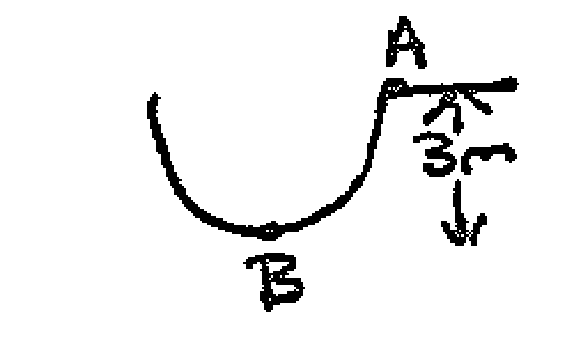
- A microwaves turntable spins at 3.0 revolutions per minute It has a 250.0g cup of coffee placed at 15.0cm from its centre. Find its :
- Period of revolution
- Tangential velocity
- Centripetal force on the cup.

- A mass of 100.0g is whirled in a horizontal circle making a 5.00⁰ angle to the horizontal. The string is 0.800m long. Find the:
- max whirling speed in m/s and rpm.
- Tension in the string

- A cyclist is travelling at a constant speed of 7.0 ms⁻¹ round a curve in a horizontal road. The centre of mass of the cyclist and her bicycle moves in a circle which has a radius of 8.0m. The mass of the cyclist and her bicycle is 90 kg.
- What is the magnitude of the net force which causes the cyclist and her bicycle to move in a circular motion?
- On a diagram show all external forces acting on the bicycle and rider as she rides round the curve and indicate the directions clearly. Hence explain how these forces create the net force calculated in a)

- At a cycling velodrome the 25.0 m radius corners are banked so that the riders can travel around the bend without relying on a horizontal frictional force on the tyres to keep them on track.
- Discuss how the angle helps keep the cyclist on the track.
- What is the angle of banking to the horizontal if the track has been designed for speeds of 20 ms⁻¹.

- A stunt plane flies in a vertical circle so that she is weightless at the top of the loop. The plane’s engines are idling so they don’t contribute to the planes speed at the bottom of the loop. If the radius of the circle is 600m and her mass is 62kg, find:
- The speed of the plane at the top of the loop.
- The speed of the plane at the bottom of the loop.
- Her apparent weight (reaction force) at the bottom of the loop.

- At a funfair in Canada, Tim rides a sled down a 20 m tall icy slope into a 5 m radius loop. Total mass of Tim and sled is 150 kg.
- Find the loss of potential energy as sled moves from A B.
- What is the speed of sled at point B?
- What is speed of sled at point C? Will it fall down?
- What is the reaction force at B?

Revision – Equilibrium

- A 20 kg boy sits 1.5 m from the pivot of a see-saw. A 30 kg girl tries to find where to sit to balance the boy
  - What is the force supplied to the pivot by the plank?
  - Where must the girl sit?

- A uniform horizontal 2.50 m beam AD of mass 15.0 kg is attached to the front wall of a shop. It is strengthened and supported by a steel bracket BC that is attached to the beam AD at point B, 1.00 m from end D, and to the wall at point C, 1.00 m below end D. Beam AD supports a uniform sign of mass 4.00 kg. The sign is attached to beam AD at points X and Y using two light steel cables. They are 0.20 m and 1.00 m respectively from end A, both making angles of 70.0° to beam AD. The light steel cables are attached at equal distance from the centre of the sign as shown in the diagram above.
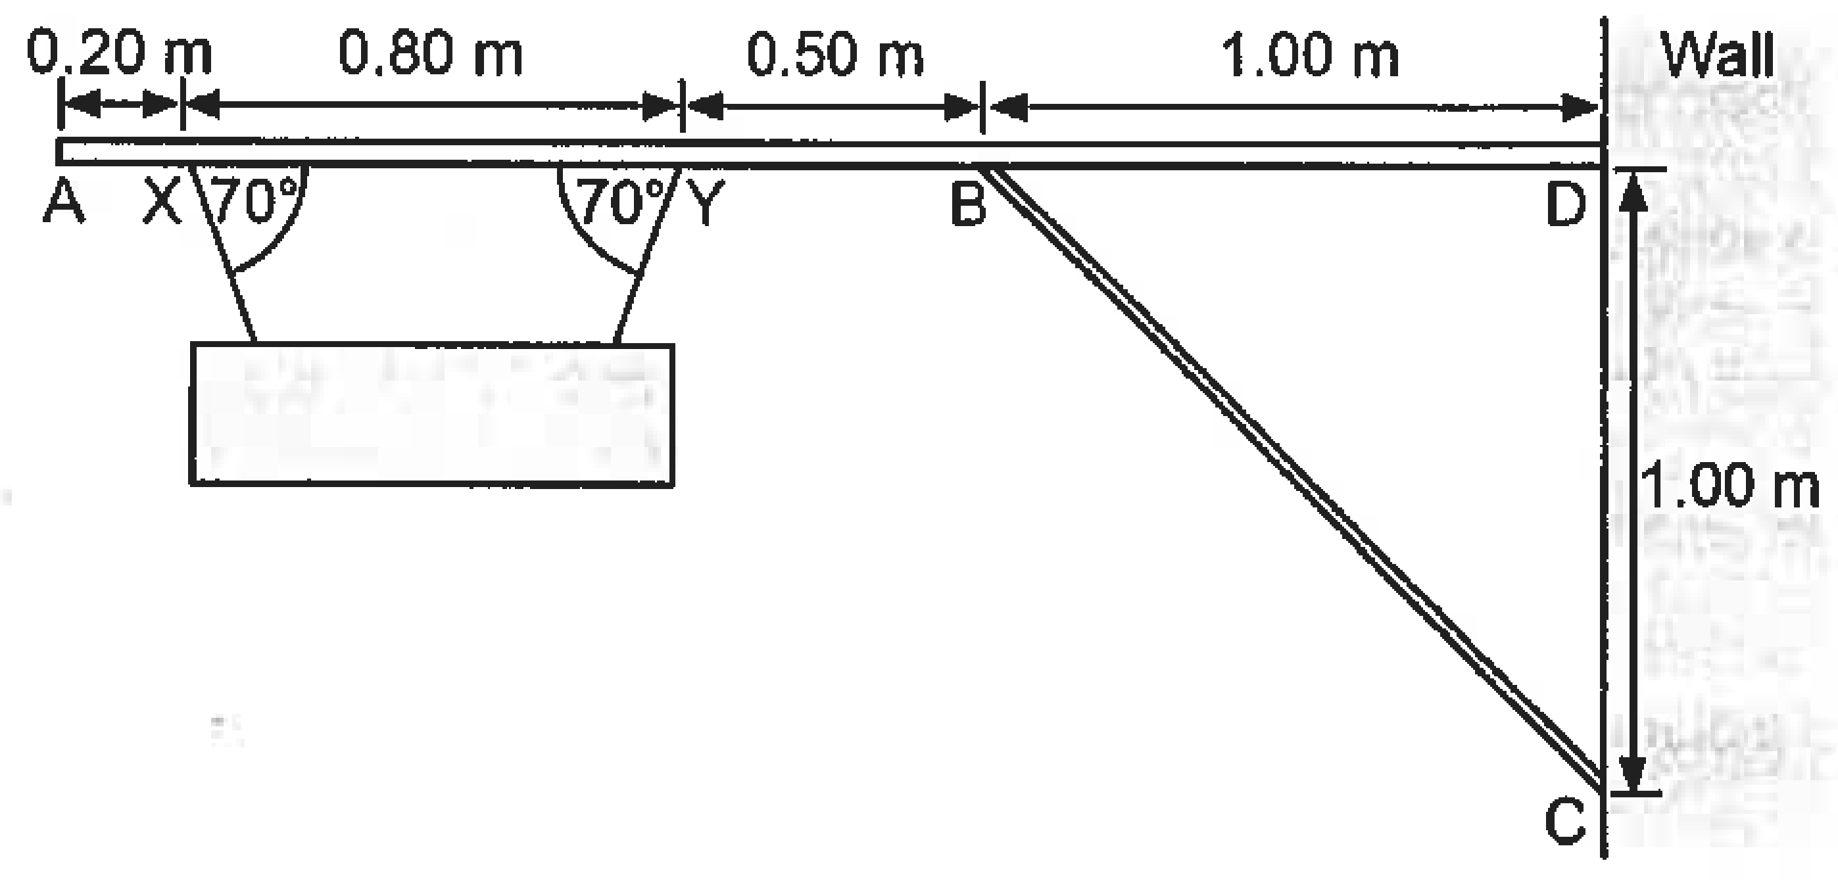
        - Calculate the tension in each of the light steel cables supporting the sign.
        - Calculate the compression force in the steel bracket BC, if the force only acts along BC.

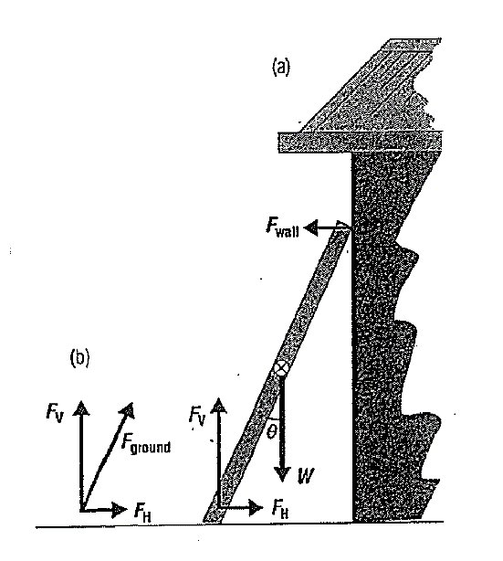
- A 5.00 m long ladder leans against a wall at a point 4.00 m above the ground. The ladder is uniform and has a mass of 12.0 kg. Assume wall is frictionless
(not the ground). Determine the forces exerted on the ladder by the
ground and wall.

- A 3.00 m long plank with a mass of 10.0 kg is held by a cable at point P, 0.200 m away from the upper end of the plank. The angle between plank and ground is 20.0⁰ and the angle between plank and cable is 30.0⁰. A 2.00 kg cat moves up the plank up to point Q, 2.40 m from the bottom, point O. Calculate the tension in the cable
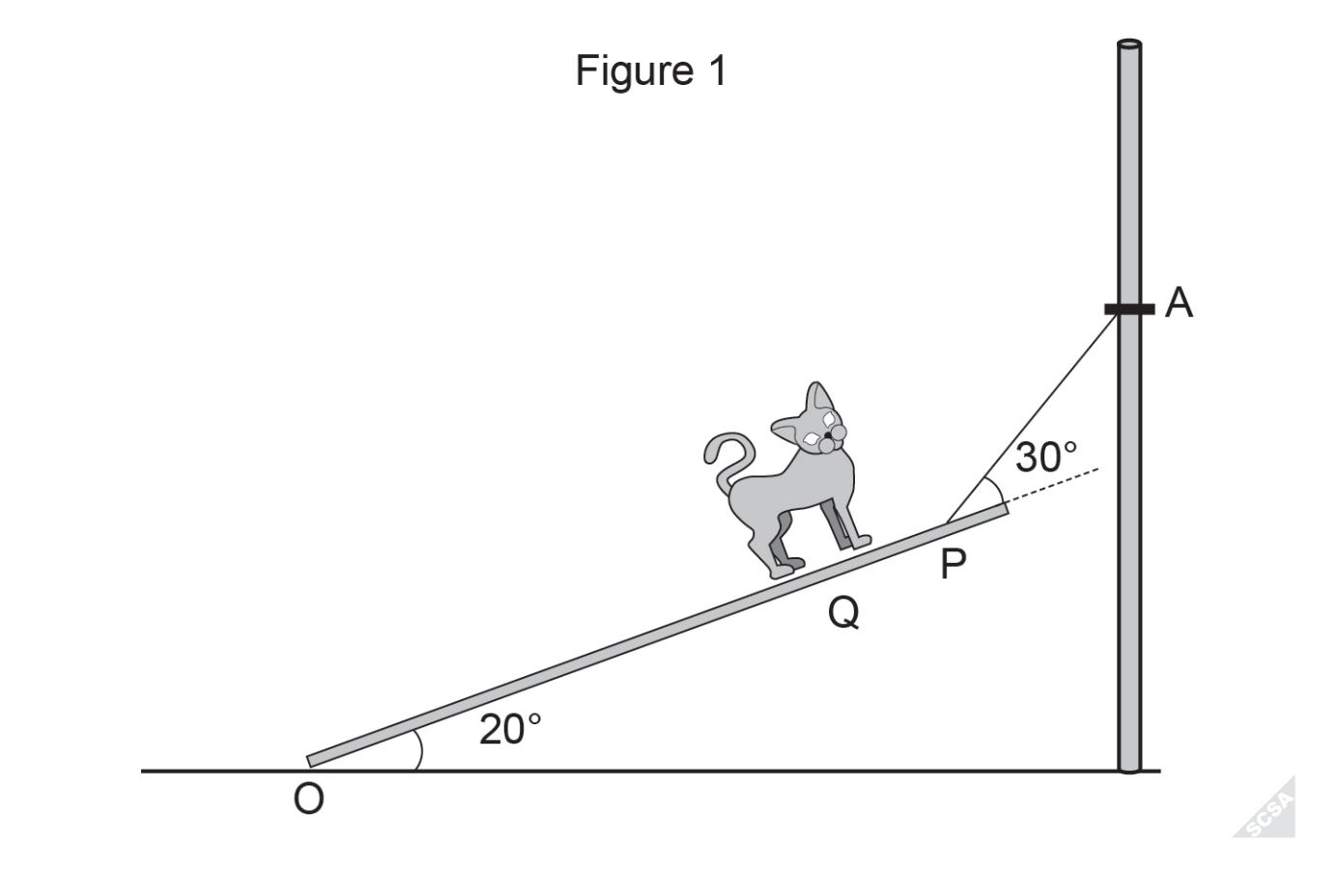
- The cable is then moved from point A to point B and the angle of 30.0⁰ is maintained between the cable and plank. The angle between the plank and ground changes to 25.0⁰ as in figure 2. Assume pivot point at O. State whether the tension in the cable increases or decreases.
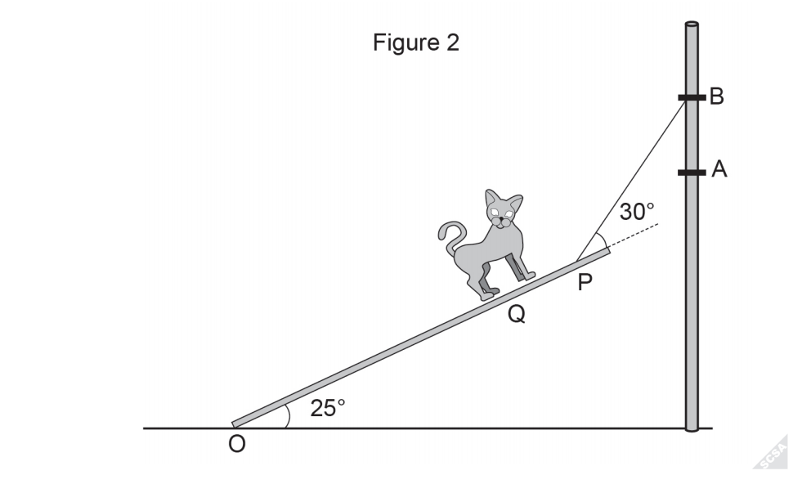

Revision – Orbits
- An exoplanet is a planet that revolves around a star that is not our sun. Assume the planets orbit is circular. Details of the star and planet are below:
Mass of star M_{s} = 2.15 x 10³⁰ kg
Mass of exoplanet M_{p} = 1.95 x 10²⁷ kg
Distance between their centers d_{sp} = 7.50 x 10⁹m

- Show that the magnitude of the gravitational force acting on the exoplanet is 4.97 x 10²⁷ N.
- Calculate the exoplanet’s orbital velocity.
- Calculate the exoplanet’s orbital period and express in hours.
- If a 2nd exoplanet, (B), was double the mass and at a radius three times the current exoplanet’s radius, determine the period of the of exoplanet B.

Bibliography

Physics Classroom, n/a, 2010, http://www.glenbrook.k12.il.us/gbssci/phys/Class/circles/u6l1c.html

The Physics Classroom, 2014, 27/11/2014 ,http://www.physicsclassroom.com/class/circles/Lesson-1/Speed-and-Velocity

- Jeff Cahill. (2011). Physics Content and Contexts. Melbourne: Pearson Heinemann.
- Neil Champion. (2014). Physics Units 1 & 2. Nelson .
- Parkinson, J. (2005). Phyzzing through Physics.
- SCASA. (2015). Retrieved from ATAR exam paper2.
- SCASA. (2018). Retrieved from ATAR exam paper2.

